CODE FOR PHARMACY MANAGEMENT

import mysql.connector as m
con=m.connect(host='localhost',user='root',password='parth0011',database='pharmacyy')
c=con.cursor()

# to insert a medicine
def insert_med():
mID=int(input("Enter medicine id= "))
n=input("enter medicine name: ")
mf=input("enter manufacturer: ")
dm=input("enter date of manufacture: ")
de=input("enter date of expiry: ")
qnt=input("enter quantity: ")
price=input("enter price: ")
q=""insert into medical values({},'{}','{}','{}','{}',{},{})".format
(mID,n,mf,dm,de,qnt,price)

c.execute(q)
con.commit()
print("....medicine inserted....")

#to display medicine
def show_medicine():
q="select * from medical"
c.execute(q)
r=c.fetchall()
for i in r:
print(i)

#to restock medicine
def restock():
med_id=int(input("enter medicine id:"))
qty=int(input("enter quantity to add:"))
q="update medical set m_qnt= m_qnt+ %s where m_id=%s"
d=(qty,med_id)
c=con.cursor()
c.execute(q,d)
print("\n")
print("+++"*10)
print("medicine restocked....")
print("+++"*10)
print("\n")
con.commit()

#to delete a medicine
def delmed():
md=int(input("enter medicine id:"))
c=con.cursor()
q="delete from medical where m_id='%s'"% md
c.execute(q)
print("\nMedicine deleted........\n")
print("----"*15)
print("\n\n")
con.commit()

#function for billing
def bill():
bn=input("Enter bill no.: ")
n=input("Enter customer's name: ")
b=input("enter bill date(yyyy-mm-dd):")
am=0
med=""
c=con.cursor()
while True:
mid=input("enter medicine id:")
q="select * from medical where m_id='%s'"%mid
c.execute(q)
res=c.fetchone()
if res==None:
print("\nNo medicine available with this ID\n")
print("$$$"*15)
else:
price=int(res[-2])
med+=res[1]+""
print("price of medicine is :",price)
qty=int(input("enter the quantity to be purchased:"))
bill=price*qty
am+=bill
print("amount for medicine:",am)
ans=input("are there more medicine to be purchased:")
if ans.lower()=="no":
print("calculating your bill:")
break
print("total bill amount is:",am)
q="insert into bill1 values(%s,%s,%s,%s,%s)"
data=(bn,n,med,am,b)
c.execute(q,data)
con.commit()
print(" ...bill generated.... \n\n")

while True:
print("****"*15)
print("\t\t\tDMS MEDICAL STORE")
print("****"*15)
print("\n")
print("Press 1 - Add New medicine")
print("Press 2 - Restock a medicine")
print("Press 3 - Show all medicines")
print("Press 4 - Delete a medicine")
print("Press 5 - Billing")
print("Press 6 - to exit")
print("\n")
choice=int(input("Enter your choice: "))
if choice==1:
insert_med()
elif choice==2:
restock()
elif choice==3:
show_medicine()
elif choice==4:
delmed()
elif choice==5:
bill()
elif choice==6:
print("\t\t Thanks for visiting!!")
print("\t\t Have a good day!!!\n")
print("-----"*10)
else:
print("Wrong choice")

OUTPUTS

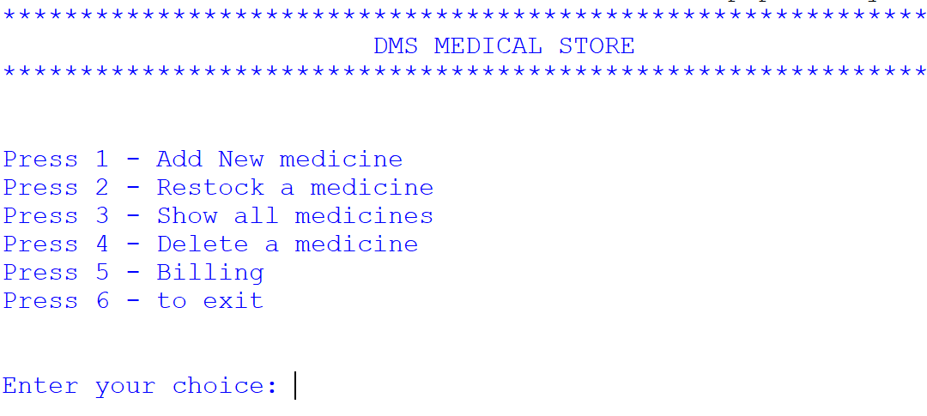

1)Inserting a medicine

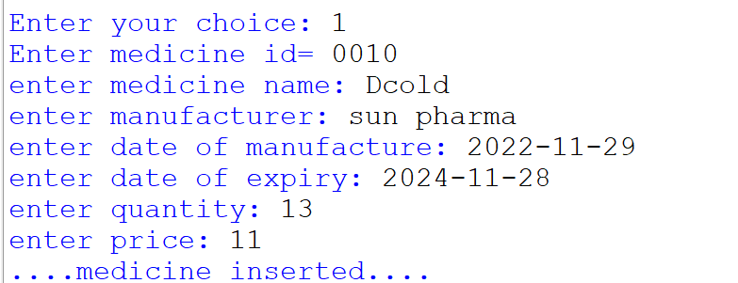

2)Restocking a medicine
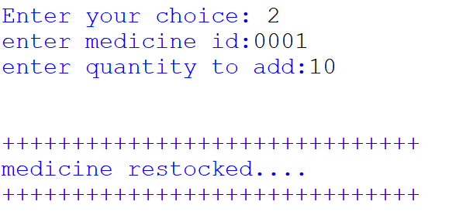

3)Showing all the medicines
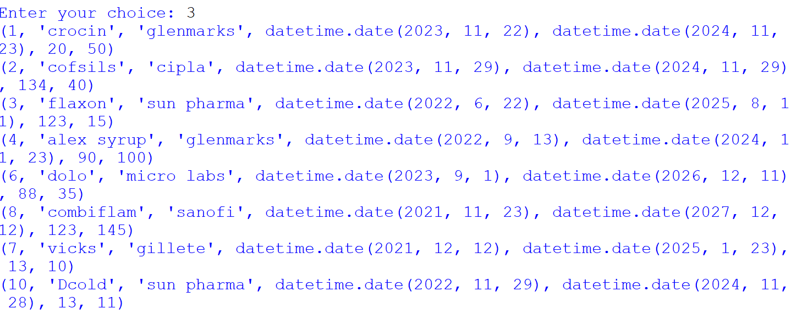

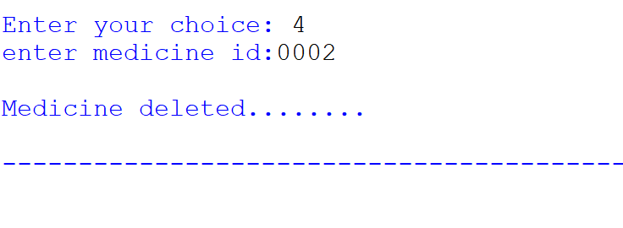
4)Deleting a medicine

5)Billing
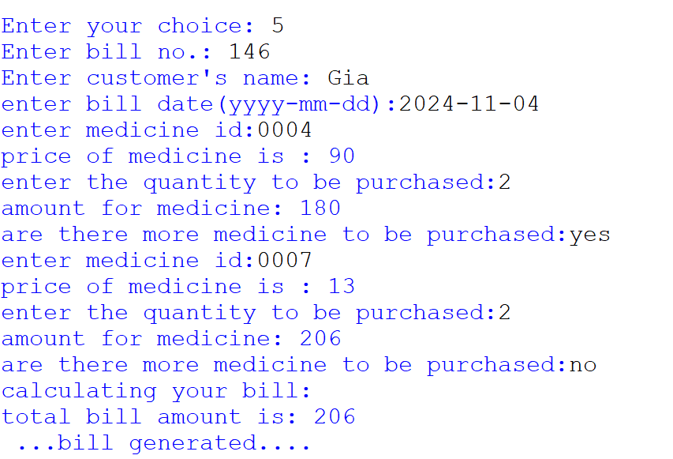

6)Exit
